Install the ESP32 plugin in the Arduino IDE
When you open the Arduino IDE, select Tools > Board, you will find that the Arduino IDE only has Arduino AVR Boards and no esp32.
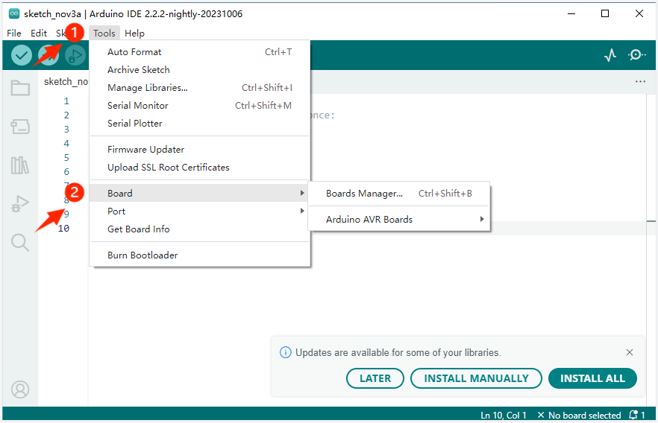
This time we use the control board is the ESP32 control board, so we need to install the ESP32 board in the Arduino IDE. Follow these steps:
- Open File >Preferences
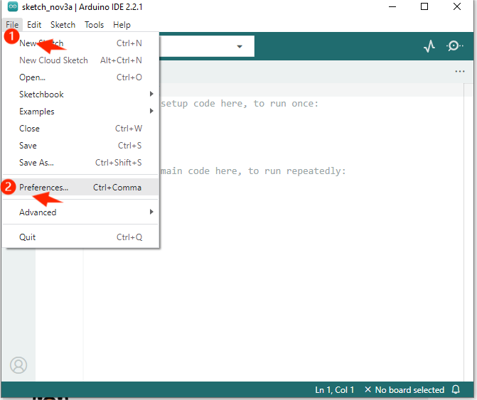
- Add the development board management address URL.
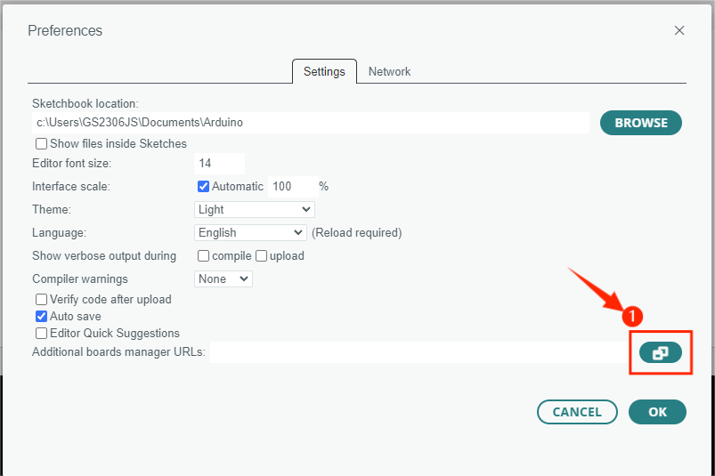
3. Copy the URL in the lower box and add it to the "Additional Boards Manager URLs".
http://arduino.esp8266.com/stable/package_esp8266com_index.json
https://www.arduino.me/package_esp32_index.json
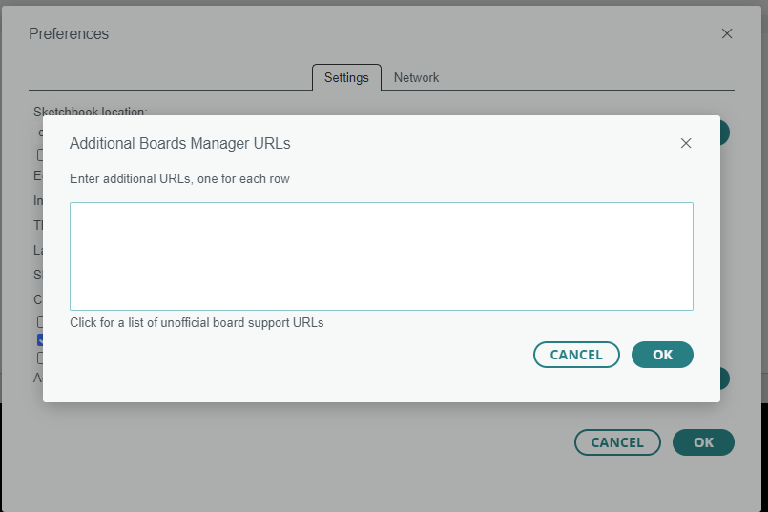
4.After adding the URL, click "OK".
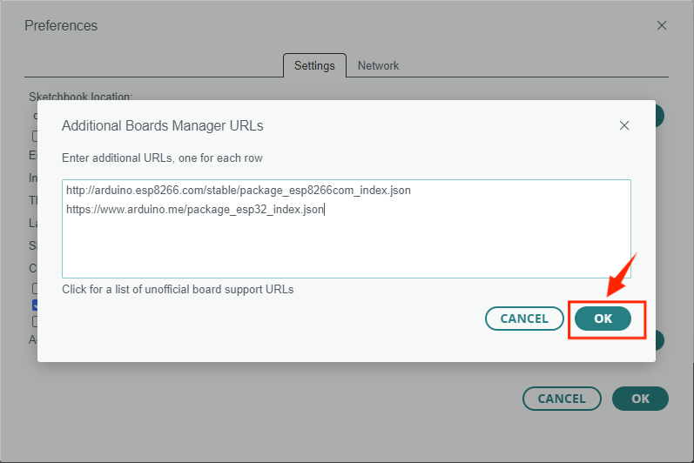
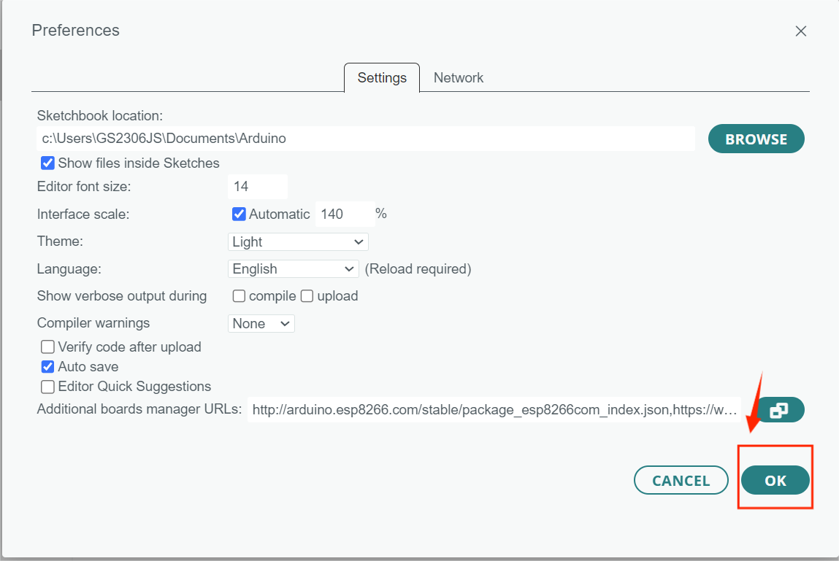
5.Click Tools > Board > Boards Manager.

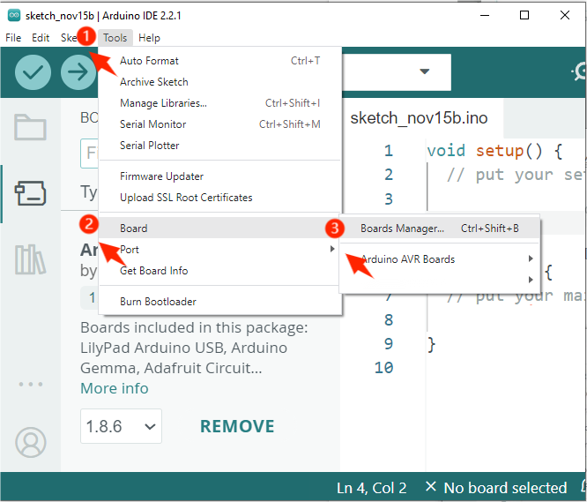
6. Search for "ESP32" in the search bar of BOARDS MANAGER, select version V2.0. 11 and install.
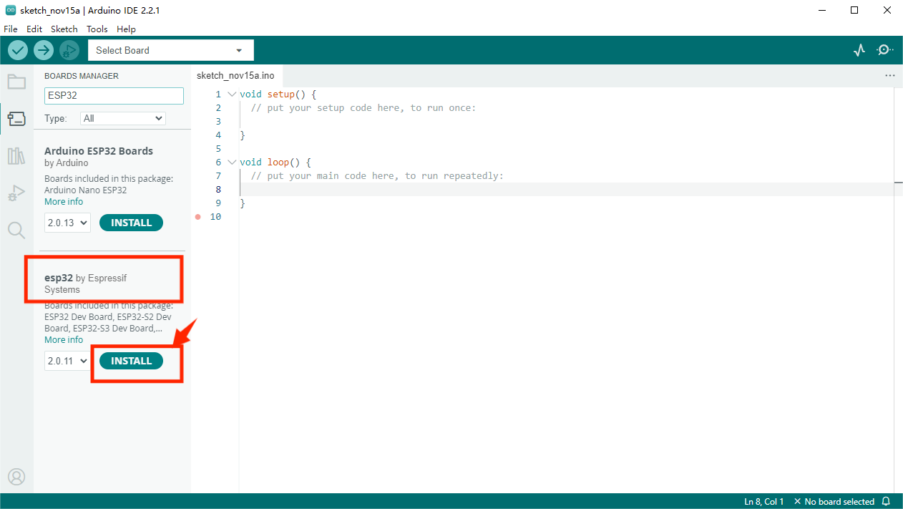
7.If the following screen appears, please wait until the installation is complete then turn off the Arduino IDE.

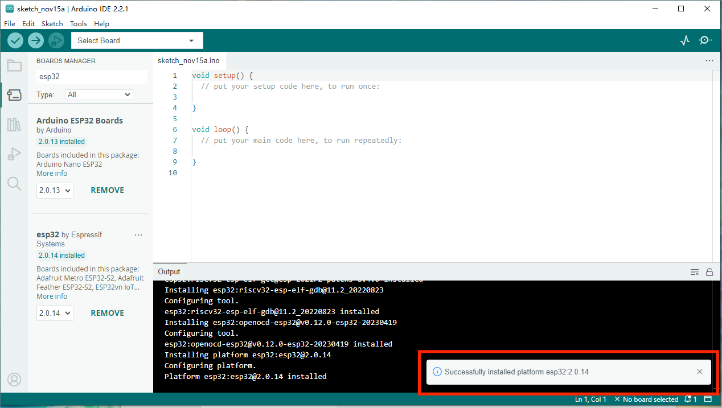
8. Open the Arduino IDE again and select Tools > Board. You will see the esp32 board appear.
